**Attachment 8: Draft Conditions**

**DEFERRED COMMENCEMENT**

Under section 4.16(3) of the Act, this development application has been determined by granting of Deferred Commencement consent, subject to the following matter(s):

1. The Development Consent shall not operate until Council has been satisfied as to the following matters:
2. **Registration of Biodiversity Stewardship Agreement**

The developer, at its own cost, must establish the subject property of Lot 3 DP717776, 71 Fig Hill Lane, Dunmore under a Biodiversity Stewardship Agreement, generally in accordance with the Letter of Undertaking dated 31 December 2020. The Biodiversity Stewardship Agreement must be registered on the title and the Biodiversity Stewardship Agreement must be under active management (Total Fund Deposit satisfied) prior to commencement of this development consent.

1. **Registration of Easement for Water Supply**

The developer, at its own cost, must obtain an easement across the adjoining property of Lot 1, DP 219199, 413 Riverside Drive, Dunmore for the provision of water supply and servicing. The easement must be established generally in accordance with the Water Main Path Plan prepared by CEH Consulting Pty Ltd dated 19 February 2021.

The minimum easement width shall be 1.5 metres, or wider where necessary to enable construction of, access to, and maintenance of, the proposed pipeline within the easement.

1. The developer must satisfy Council, within 36 months of the date shown on the top of this consent, that the matters specified in condition number (i) have been complied with.
2. If compliance with the matters contained in condition number (i) necessitate a substantial variation to the development approved by this deferred commencement consent, a new development application must be submitted.

**Once Council is satisfied that the matters contained in condition number (i) have been complied with and the developer has been notified in writing of such compliance, the following conditions shall apply in respect of the approved development:**

This development consent has been divided into different parts according to where, during the development process, each condition may be most relevant. Some conditions may be appropriate to more than one part. All conditions must be complied with.

Part A – Administration Condition

1. Consent

This consent relates to the:

* Demolition of the existing derelict structure and select retaining walls; and
* Construction of an Eco-tourist Facility as shown on the approved plans.

1. Bushfire Authority, Controlled Activity Approval (NSW Rural Fire Service).

The NSW Rural Fire Service has provided recommended conditions pursuant to section 100B of the Rural Fires Act 1997. The recommended conditions are detailed in Part G of this Development Consent.

1. Construction Certificate & Principal Certifier Notification

Before any site works, building or use is commenced, the person having the benefit of the development consent must:

a. obtain a Construction Certificate from Shellharbour City Council or other accredited certifier, and

b. appoint a Principal Certifier.

1. Prescribed Conditions

This development consent is subject to the prescribed conditions made under the *Environmental Planning & Assessment Regulation 2000*.

1. Development in Accordance with Plans and Documents

The development must be in accordance with the approved Development Application plans and documents as endorsed by Council's Stamp except as modified by conditions of this consent.

|  |  |  |  |
| --- | --- | --- | --- |
| **Name of Plan/Document** | **Prepared By** | **Drawing/Document No./Revision** | **Drawing/Document Date** |
| Site Plan | Norden Jago Architects | Job No. CON00116 Drawing No. 001I | 16.03.2021 |
| Demolition Plan | Norden Jago Architects | Job No. CON00116 Drawing No. 003H | 16.03.2021 |
| Tree Survey and APZ | Norden Jago Architects | Job No. CON00116 Drawing No. DA.013D | 15.02.2021 |
| Proposed Building and Zoning | Norden Jago Architects | Job No. CON00116 Drawing No. DA.014D | 15.02.2021 |
| Basement Clifftop Lodges Plan | Norden Jago Architects | Job No. CON00116 Drawing No. 100J | 16.03.2021 |
| Ground Floor Plan | Norden Jago Architects | Job No. CON00116 Drawing No. 101N | 16.03.2021 |
| First Floor Plan | Norden Jago Architects | Job No. CON00116 Drawing No. 102N | 16.03.2021 |
| Roof Top Plan | Norden Jago Architects | Job No. CON00116 Drawing No. 103J | 16.03.2021 |
| Roof Plan | Norden Jago Architects | Job No. CON00116 Drawing No. 104J | 16.03.2021 |
| Basement Clifftop Lodges Detail Plan | Norden Jago Architects | Job No. CON00116 Drawing No. 110J | 16.03.2021 |
| Ground Floor Detail Plan | Norden Jago Architects | Job No. CON00116 Drawing No. 111L | 16.03.2021 |
| First Floor Plan Detail Plan | Norden Jago Architects | Job No. CON00116 Drawing No. 112K | 16.03.2021 |
| Rooftop Plan Detail Plan | Norden Jago Architects | Job No. CON00116 Drawing No. 113J | 16.03.2021 |
| Section 3D Plan | Norden Jago Architects | Job No. CON00116 Drawing No. 200J | 16.03.2021 |
| South and West Elevations Plan | Norden Jago Architects | Job No. CON00116 Drawing No. 300J | 16.03.2021 |
| North and East Elevations Plan | Norden Jago Architects | Job No. CON00116 Drawing No. 301J | 16.03.2021 |
| Bushfire Report | Travers Ecology | 20NJA02-BR002 | 23.03.2021 |
| Eco- tourist Facility - Draft Plan of Management | Planning Lab | - | 20.10.2020 |
| Environmental Sustainable Design Report | Wood & Grieve Engineers | Reference 43176 | 15.10.2019 |
| Vegetation Management Plan | Cumberland Ecology | Report No. 17231RP4  Version 2 | 12.01.2021 |
| Wastewater Management Plan | Martens Consulting Engineers | Job no. P1907197JR03V02  Revision No. 2 | 21.10.2020 |
| Waste Management Plan | Dickens Solutions | - | 28.03.2020 |
| Landscape Plans | Sturt Noble Associates | Drawing Nos DA1919-01 to DA1919-08 (inclusive) | 01.10.2020 |
| Heritage Impact Statement | Urbis | Project Code No. P21194  Report 01 | 20.10.2020 |
| Concept Stormwater Management Plans | Martins Consulting Engineers | Job no. P1907197  Drawing Nos: |  |
| PS01-B300-E | 15.10.2020 |
| PS01-B310-C | 15.10.2020 |
| PS01-C500-B | 15.10.2020 |
| PS01-E100-F | 21.10.2020 |
| PS01-E200-B | 27.09.2020 |
| PS01-E600-A | 15.10.2020 |
| PS01-E700-C | 15.10.2020 |
| Concept Stormwater Management Report | Martins Consulting Engineers | Job no. P1907197JR04V01. | 21.10.2020 |
| Aboricultural Comment | Our Garden Path |  | 27.02.2021 |
| Water Main Path | CEH Consulting Pty Ltd | Drawing No. A1-0215286_EASE | 19.02.2021 |
| APZ Tree Survey | Our Garden Path | - | 13.01.2021 |
| Biodiversity Development Assessment Report | Cumberland Ecology | - | 10.10.2019 |
| Response to Council’s Request for Further Information for DA0563/2019 in relation to Biodiversity Issues | Cumberland Ecology | - | 19.10.2020 |
| Site Investigations Assessments | eiaustralia | E24306.E03_Rev0 | 01.10.2019 |
| Updated Draft Walking Track Management and Maintenance Plan | Cumberland Ecology | - | 13.01.2021 |
| BAR Intersection Design | Barker Ryan Stewart | Plan no. CC190065-02-01 Rev B | 13.01.2021 |

1. Compliance with Notations on Drawings

Works must comply with any notations highlighted on the approved plans and specifications.

1. Utility Services

The developer must meet the full costs to adjust/repair/relocate any affected utility services. The developer must make the necessary arrangements and upgrades with the service authorities.

1. Other Approvals

All necessary development consents and/or other approvals for works on Lot 501 DP 1174897 and/or Lot 51 DP 1012246 are to be obtained prior to the commencement of works associated with the development subject of this consent. Any works required on Lot 501 DP 1174897 and/or Lot 51 DP 1012246 are to be carried out and completed to the satisfaction of the Principal Certifier, prior to the issue of any Occupation Certificate of the development.

PART B – PRIOR TO THE ISSUE OF A CONSTRUCTION CERTIFICATE

9. Amendments to Approved Plans

The amendments described below must be incorporated into the development and be submitted to Council for approval prior to the lodgement of any Construction Certificate Application with the Principal Certifier.

1. An Arborists Report is to be provided which considers the impacts of the widening works to Fig Hill Lane and provides recommendations as to how all significant, native trees and vegetation can be retained.

The report is to be prepared by an arborist who is eligible for membership as a ‘Consulting Arborist’ with the National Arborists Association of Australia or the Institute of Australian Consulting Arboriculturalists and who has obtained a Level 5 Certificate in Horticulture/Arboriculture or equivalent.

1. Design details and/or amended plans which demonstrate that the approved Ecologically Sustainable Development (ESD) Report prepared by Wood & Grieve Engineers dated 15 October 2019 is compatible with the approved architectural plans;
2. A lighting schedule prepared by an qualified professional with management provisions for vehicle ingress and egress, operation of the terrace, bar/restaurant, swimming pool area and car park;
3. An arborists report is to be prepared by an arborist who is eligible for membership as a ‘Consulting Arborist’ with the National Arborists Association of Australia or the Institute of Australian Consulting Arboriculturists and who has obtained a Level 5 Certificate in Horticulture/Arboriculture or equivalent which provides recommendations on tree protection measures and design details to ensure that the trees located adjoining the proposed car parking area in the north western corner of the site, in close proximity to the boundary with Lot 51 DP 1012246, 69 Fig Hill Lane are not unreasonably affected by the development. Any recommendations of this report must be notated on the plans submitted as part of the Construction Certificate Application;
4. The extent of the Coastal Wetlands area must be surveyed and identified by markers, and that the Plan of Management for the walking tracks be updated to require that no access or activities that may result in impacts to the Coastal Wetlands area be permitted;
5. The visible light reflectivity (reflectivity index) of the roof and other external building materials/colours (including exposed windows) must not exceed 20%. Written evidence that this requirement is not exceeded must be provided to Council, for approval, prior to the issue of the Construction Certificate.
6. A revised stormwater plan which includes provision for the Easement for Pipeline and Water Storage in accordance with restriction (B) on DP 1174897 is to be provided. The water storage area is to be provided beneath the driveway area and a pipeline provided to the property boundary with Lot 501 DP 1174897. The plan is to be provided to Council, for approval, prior to the issue of the Construction Certificate.
7. The architectural plans are to be revised to comply with the Asset Protection Zone recommendations and Figure 5 within the Bushfire Report dated 23 March 2021 prepared by Travers Ecology. In this regard, the south eastern corner of the Clifftop Lodge A building is to be relocated 1m to the north west.

10. Section 7.11 Contributions

A contribution of $1,891.07, subject to annual indexation, must be paid to Council towards the provision of public amenities and public services prior to the issue of the Construction Certificate. This amount has been calculated in accordance with Shellharbour City Council’s Local Infrastructure Contributions Plan 2019 9th Review 14 August 2019 in the following manner:

* Non-residential contribution – Tier 3 - $1,891.07.

The contribution amount contained in this condition is the base rate indexed to the date the consent is issued. The contribution amount will be adjusted in accordance with the indexation methods detailed in the Contributions Plan. Current indexed rates are available from Council.

The Contributions Plan may be inspected or a copy purchased at the Customer Service Counter at Council’s offices, or downloaded from [www.shellharbour.nsw.gov.au](http://www.shellharbour.nsw.gov.au)

1. Building Plan Approval - Sydney Water

The approved plans must be submitted to a Sydney Water Tap in™ to determine whether the development will affect Sydney Water wastewater and water mains, stormwater drains and/or easements, and if any requirements need to be met. Sydney Water’s Tap in™ online service is available at:

<https://www.sydneywater.com.au/SW/plumbing-building-developing/building/sydney-water-tap-in/index.htm>

The Certifier must ensure that Sydney Water Tap in™ has issued the appropriate electronic approval prior to the commencement of any works.

**12**. **Building - Swimming Pool Design & Construction**

The design and construction of the swimming pool and associated fencing and equipment must comply with:

(a) The *Swimming Pools Act 1992 & Regulation 2008*;

(b) Building Code of Australia

(c) Australian Standard 1926.1-2007 - Swimming Pool Safety;

(d) Councils Development Control; and

(e) *Protection of the Environment Operations Act 1997*.

No water must be placed in the pool/spa until the safety fences have been completed in accordance with the approved plans and specifications and inspected by the Principal Certifier.

13. Demolition and Construction Management Plan (DCMP)

Prior to the issue of any Construction Certificate, a Demolition and Construction Management Plan must be submitted with the application for any Construction Certificate, and must include the following measures:

1. methods to ensure that all existing Right of Carriage Way Easements noted on DP 717776, that benefit other landowners, are not affected for the duration of the construction period and the DCMP;
2. dedicated construction site entrances and exits, controlled by a traffic controller, to safely manage pedestrians and construction related vehicles in the frontage roadways;
3. turning areas within the site for construction and spoil removal vehicles, allowing a forward entry and egress for all construction vehicles on the site;
4. the location of proposed Work Zones in the egress frontage roadways;
5. location of any proposed crane standing areas;
6. a dedicated unloading and loading point within the site for all construction vehicles, plant and deliveries;
7. material, plant and spoil bin storage areas within the site, where all materials are to be dropped off and collected;
8. the provisions of an on-site parking area for employees, tradesperson and construction vehicles as far as possible;
9. a detailed description and route map of the proposed route for vehicles involved in spoil removal and demolition material removal material delivery and a copy of this route is to be made available to all contractors;
10. a detailed description of locations that will be used for layover for trucks waiting to access the construction site;
11. construction program that references peak construction activities and proposed construction;
12. any potential impact to general traffic, cyclists, pedestrians and bus services within the vicinity of the site from construction vehicles during the construction of the proposed works when accessing the site and exiting onto Riverside Drive;
13. alignment with the approved waste management plan;
14. location of protective site fencing, including tree protection methods;
15. location of site storage areas/offices/equipment;
16. management of Fuels and Chemicals;
17. unexpected contamination finds and stop work protocols;
18. cultural heritage stop work protocol;
19. location of building materials for construction, e.g. stockpiles;
20. provisions for public safety;
21. provisions for temporary sanitary facilities;
22. location and size of waste containers/skip bins;
23. method used to provide construction noise and vibration management;
24. methodology utilised for the protection of Dunmore House Complex, Dry Stone Walls and Trees (Item no. I207) located at 471 Riverside Drive, Dunmore; and
25. construction traffic management details consistent with other required amendments.

The site management measures are to be implemented prior to the commencement of any works including demolition and excavation. The site management measures are to be maintained throughout the works, to maintain reasonable levels of public health, safety and amenity. A copy of the Construction Management Plan must be retained on site and is to be made available upon request.

It is the developer’s responsibility to adequately inform all construction workers, sub-contractors and supervisors to ensure that the Construction Traffic Management procedures are adhered to at all times.

**14. Heritage Interpretation Strategy**

A Heritage Interpretation Strategy must be prepared by a suitably qualified heritage consultant in accordance with the NSW Heritage Guide on Heritage Interpretation Policy.

The strategy is to provide details on how the history and significance of the site will be communicated to both the public and guests of the site. Appropriate communication methods could include information regarding public accessibility, signage and lighting, art, details of the heritage design or the display of selected artefacts (if applicable).

The interpretation strategy is to be completed by a suitably qualified consultant with experience in undertaking interpretation strategies. Any works or installations recommended within the strategy are to be implemented and/or undertaken at the site, in consultation with Council.

****15. Engineer Designed Pavement****

All car parking areas, manoeuvring areas and the access aisle, both within the site and the right of carriageway area, must be paved, drained and marked. The pavement must be designed by a qualified civil engineer and certified to be satisfactory for the expected traffic loadings from a development of this size and type. *AUSTROADS Guide to Pavement Technology* can be used as the design guideline for the pavement design.

Any laybacks or crossings must be designed to accommodate expected traffic loadings. In this regard they must be constructed to a commercial/industrial standard with the work carried out by Council or a Council approved contractor at the developer's expense, including all alteration to public infrastructure where necessary.

**16. Car Parking Space – Dimensions**

All car parking spaces must be in accordance with Shellharbour Development Control Plan 2013; Chapter 13, Section 13.2 with details of compliance displayed on the plans submitted for the Construction Certificate. All disabled parking spaces are to be in accordance with AS 2890.6 (or subsequent amendments).

17. Riverside Drive and Fig Hill Lane Intersection Treatment

The intersection between the access way and Riverside Drive must be upgraded to a BAR for vehicles heading south and turning right into the development is to be incorporated into the Construction Certificate plans for the development in accordance with the BAR Intersection Design Plan prepared by Barker Ryan Stewart dated 13 January 2021.

18. Long Service Levy

The Long Service Levy must be paid prior to the issue of the Construction Certificate.

**19. Soil and Water Management Plan (SWMP)**

Prior to the issue of the Construction Certificate, the applicant must submit to and obtain the Principal Certifiers approval of a Soil and Water Management Plan. The SWMP must clearly identify site features, constraints and soil types together with the nature of the proposed land disturbing activities and also specifies the type and location of erosion and sediment control measures. In addition, rehabilitation techniques that are necessary to deal with such activities should be referred to.

The SWMP must take into account the requirements of Landcom’s publication *Managing Urban Stormwater - Soils and Construction (2004)* thus ensuring the following objectives are achieved, namely:

1. minimise the area of soils exposed at any one time;
2. conserve topsoil for reuse on site;
3. identify and protect proposed stockpile locations;
4. preserve existing vegetation and identify revegetation techniques and materials;
5. control surface water flows through the development construction site on a manner that:

i. diverts clean run-off around disturbed areas.

ii. minimises slope gradient and flow distance within disturbed areas.

iii. ensures surface run-off occurs at non-erodible velocities.

1. ensures disturbed areas are promptly rehabilitated.
2. trap sediment on site to prevent off site damage. Hay bales are not to be used as sediment control devices. To ensure regular monitoring and maintenance of erosion and sediment control measures and rehabilitation works until the site is stabilized (includes landscaping).
3. specifies measures to control dust generated as a result of construction activities on site;

h. including measures to prevent the tracking of sediment off the site.

**20. Stormwater Discharge**

Stormwater discharge to the infiltration trenches/basins must be protected against erosion.

Details are to be submitted and be to the satisfaction to the Principal Certifier prior to the release of the Construction Certificate.

**21. Detailed Drainage Design**

A detailed drainage design of the site must be submitted and approved prior to the release of the Construction Certificate. The detailed plan must:

a. be generally in accordance with Drainage Plan (Project No. 1907197, Planset No. PS01, Release No. R07, Drawing No. PS01-E100, Revision F) prepared by Martens 7 Associates Pty Ltd on 21/10/2020;

c. indicate the method of disposal of all stormwater and must include rainwater tanks, existing ground levels, finished surface levels on all paved areas, estimated flow rates, invert levels and sizes of all pipelines;

d. be to the satisfaction of the Principal Certifier;

e. be designed to cater for a 1 in 20 year Average Recurrence Interval storm event;

f. overflow drainage paths are to be provided and be designed to cater for 1 in 100 year Average Recurrence Interval storm event;

g. comply with Council's Shellharbour Development Control Plan, unless variation is specifically noted and approved on DA concept drainage plan; and

h. provide adequate provisions for Onsite Stormwater Detention (OSD) and Water Quality in accordance with the Shellharbour City Council Engineering Code, to the satisfaction of the Principal Certifier.

**22. Protection of Site Trees**

The existing site trees to be retained must be enclosed with temporary protective fencing to prevent any activities, storage or the disposal of materials within the fenced area. Details of the design and location of the vegetation protective fencing must be shown on the building plans and must be approved by the Principal Certifier and validated by an appropriately qualified arborist prior to the issue of the Construction Certificate.

**PART C – PRIOR TO THE COMMENCMENT OF WORKS**

1. **Section 68 Approval Wastewater Treatment Approvals**

Prior to installation of the wastewater treatment system, a Section 68 application is to be submitted and approved by Shellharbour City Council, pursuant to the Local Government Act 1993. An approval to operate is required prior to system commissioning.

In addition, an operations manual is to be developed for the onsite wastewater management system as outlined in the Martens October 2020 Wastewater Management Plan Doc no. P1907197JR03V02 page 17.

1. Site Management Plan

Prior to the commencement of works, the applicant must submit to and obtain approval for a construction and site management plan from the Principal Certifier that clearly sets out the following:

a. what actions are proposed to ensure safe access to and from the site and what protection will be provided to the road and footpath area from building activities, crossings by heavy equipment, plant and materials delivery and static load from cranes, concrete pumps and the like;

b. the proposed method of loading and unloading excavation machines, building materials and formwork within the site;

c. the proposed areas within the site to be used for the storage of excavated material, construction materials and waste containers during the construction period,

d. how it is proposed to ensure that soil/excavated materials are not transported on wheels or tracks of vehicles or plant and deposited on the roadway; and

e. the proposed method of support to any excavation adjacent to adjoining buildings or the road reserve. The proposed method of support is to be certified by an appropriately qualified and experienced engineer.

**25. Soil and Water Management Plan Implementation (SWMP)**

The measures required in the Soil and Water Management Plan approved by the Principal Certifier must be implemented prior to the commencement of works.

**26. Dilapidation Report**

It is the applicant’s responsibility to notify Council of any existing damage to public areas in the vicinity of the development site through the submission of a Dilapidation Report. The report must be supported with suitable photographic records and include reference to the adjoining heritage items of Dunmore House et al and the stone walls. This information must be submitted to Council prior to the commencement of work.

**27. Tree Management**

Prior to commencement of works a project arborist must be appointed and must confirm the trees to be retained or removed as part of the development, in accordance with the APZ Tree Survey Report prepared by Our Garden Path dated 13 January 2021. The Project Arborist must be an arborist who is eligible for membership as a ‘Consulting Arborist’ with the National Arborists Association of Australia or the Institute of Australian Consulting Arboriculturists and who has obtained a Level 5 Certificate in Horticulture/Arboriculture or equivalent. The Project Arborist must oversee the arboricultural related works during both the demolition and construction phases of the works.

In the event that any of the trees not identified for removal are damaged, the Project Arborist must be contacted as soon as possible. The Arborist is required to recommend remedial action so as to reduce any long term adverse effect on the tree’s health. This remedial action must commence as soon as practically possible. Council must be notified of any damage to the trees to be retained, and if they are required to be removed, may require that works cease and a modification (s4.55 Environmental Planning & Assessment Act) be submitted to Council for assessment, as additional tree removal may affect the offsetting requirement under the Biodiversity Conservation Act 2016.

All trees to be retained will require tree protection fencing to be installed prior to any works occurring. This fencing must be located no closer than the drip line of individual trees. The fencing must be designed so as to stop traffic movements over the root zones, restrict canopy damage and stop spoil from being spread over the basal area of trees to be retained. Clear fencing is also to be erected along the boundaries of the Biodiversity Stewardship area to prevent any encroachment into this area during works.

28. Fauna Management

The recommendations of the amended Cumberland Ecology Vegetation Management Plan 12 January 2021 Sections 4.4, 4.5 including pre-clearing and pre-demolition surveys must be implemented by the project ecologist. A report outlining the works methodology, recommended actions and any subsequent recommendations is to be provided to Council for approval, prior to the commencement of any works on site, including tree removal or demolition works

29. Implementation of the Demolition and Construction Management Plan (DCMP) and Site Management Plan

Prior to commencement of works, the recommendations outlined within the Demolition and Construction Site Management Plan (DCMP) relevant controls need to be in place prior to the commencement of works. These controls are to be maintained throughout the entire demolition, excavation and construction phases of the development and for a minimum three (3) month period after the completion of the project.

The controls listed under the DCMP are to be maintained throughout the entire demolition, excavation and construction phases of the development and for a minimum three (3) month period after the completion of the project.

An inspection is required to be undertaken by the Council Engineer and Environment Officer one week prior to the commencement of works to ensure these recommendations have been implemented.

1. **Food Premises - Plans & Specifications**

Details of the construction and fit out of food premises (including any store rooms) must be submitted to the Principal Certifier.

The plans and specifications must demonstrate compliance with the following:

1. *Food Act 2003* (as amended);
2. *Food Regulation 2015* (as amended);
3. *Food Standards Code* as published by Food Standards Australia;
4. *New Zealand and Australian Standard AS4674:2004 Design, Construction and fit out of food premises* (as amended); and
5. Sydney Water - Trade Waste Section.

An area must be provided for the garbage bins that is:

1. provided with a hose tap connected to the water supply;
2. paved with impervious floor materials;
3. coved at the intersection of the floor and the walls; and
4. graded and drained to a waste disposal system in accordance with the requirements of the relevant regulatory authority (Sydney Water).

**PART D - DURING DEMOLITION AND CONSTRUCTION WORKS**

1. Demolition - WorkCover, AS 2601 & *Work Health & Safety Act 2011*

Demolition work must:

a. be carried out in accordance with the requirements of the WorkCover Authority of New South Wales;

b. be carried out in accordance with the *Work Health & Safety Act 2011;*

c. be carried out by a WorkCover licensed contractor where demolition work involves the removal of any materials containing asbestos; and

d. be carried out in accordance with the provisions of AS 2601-2001: The Demolition of Structures (or subsequent edition/s).

1. Contamination - Unexpected Finds Contingency

Should any contamination or suspect material be encountered during site preparation, earth works, construction or any other stage of the development, then works must cease immediately and a suitably qualified consultant engaged to conduct a thorough contamination assessment.

In the event that contamination remediation is required, all works must cease and the Council must be notified immediately. The contamination assessment must be submitted to Council for Approval.

All recommendations provided in the contamination assessment must be followed as stipulated.

1. Cultural Heritage

A stop work protocol must be implemented for any potential heritage items found during excavation including ceasing work immediately if any Aboriginal objects are found/uncovered, secure the site and inform Heritage NSW (Department of Premier and Cabinet) and Shellharbour Council's Aboriginal Liaison Officer immediately.

**34. Protection of Site**

The land to which this consent relates must be fenced and enclosed to protect the entry or access to the land and site by lawful persons. The fencing must be in place before demolition works commence.

During demolition and construction works, the applicant/builder is required to ensure the protection and preservation of all boundary fencing or boundary walls between the subject site and adjoining properties. Any damage caused as a result of such works will be at the full cost of the applicant/builder.

35. Obstruction of Road or Footpath

The use of the road or footpath for the storage of any building materials, waste materials, temporary toilets, waste or skip bins, or any other matter is not permitted unless separately approved by Council under *Section 138 of the Roads Act.* Penalty infringement notices may be issued for any offences and severe penalties apply.

**36**. **Open or Occupy a Roadway or Footpath (Section 138 Roads Act 1993)**

Prior to any physical works within Council's road reserve such as (but not limited to) installing a driveway or connecting stormwater facilities or other utilities, you will need to apply for approval under Section 138 of the *Roads Act*.

To lodge your application you will need to submit the following information:

a. detailed engineering drawings of the proposed works in the road and footpath area;

b. traffic management plan;

c. provision of public risk insurance; and,

d. details of timing and length of works.

37. Traffic Disruption

During any construction works on the public road (Riverside Drive) that is associated with this approval, the developer must provide appropriate signage and traffic control facilities as per the requirements of AS 1742.3 and the RTA (RMS) ‘Traffic Control at Works Sites’ manual and any conditions provided within the Section 138 application pursuant to the *Roads Act*.

38. Demolition and Construction Site Management Plan (DCMP)

The developer is responsible for all aspects contained within the DCMP for the duration of the build.

**39. Maintenance of Soil and Water Management Plan (SWMP)**

The soil and water management controls must be maintained at all times during each stage of the development and checked for adequacy daily. The controls must not be removed until the development is completed and the disturbed areas have been stabilised.

Maintenance must include but is not limited to ensuring:

a. all sediment fences, sediment traps and socks are properly placed and are working effectively and,

b. drains, gutters and roads are maintained clear of sediment at all times.

**40. Earthworks Cut, Fill and Grading**

The maximum grading of cut or fill shall be 45 degrees (1:1) where there is no retaining wall or no other method of stabilising cut or fill during construction. The maximum depth of fill on any portion of the allotment shall be 1.0 metres. The maximum depth of cut on any portion of the allotment shall be 1.0 metres. Cut areas may exceed 1.0 metre provided the retained sections are located within the confines of the external walls of the buildings.

**41. Excavation & Stormwater Drainage**

There must be no loss of support of the existing stormwater drainage line as a result of excavation of the site.

**42. Retaining Walls**

Any retaining wall must be located wholly within the property, including footings and agricultural drainage lines. Construction of retaining walls or associated drainage work along common boundaries must not compromise the structural integrity of any existing structures.

**43. Protection Fencing**

The tree protection fencing must be maintained intact at all times throughout the period of building work on the site. Machinery, structures, storage/disposal of any building materials and the like, must not be located within the fenced area at any time. Evidence provided by a qualified arborist on the design amendments and tree protection measures required under Condition 25 for the two Fig Trees located at the entrance to the site must be provided to Council to demonstrate compliance with the condition.

**44. Hours of Work During Construction**

Noise generating activities, including excavation, construction and delivery of equipment and materials, must only be carried out between:

• 7am to 5pm Mondays to Fridays

• 8am to 1pm Saturdays.

Work must not be carried out on Sundays or public holidays.

**45. Survey Certification**

A report from a registered surveyor must be provided to the Principal Certifier on completion of the ground floor slab formwork prior to the concrete being poured and/or prior to external walls being raised above ground floor level where there is no ground floor slab.

The report must certify all of the following:

a. the distance of the structure to all boundaries of the allotment are in accordance with the approved plans, and

b. the height of the floor level/s in relation to the natural ground level are in accordance with the approved plans.

Australian Height Datum must be used.

1. **Building Height - Survey Certification**

The building must not exceed the height shown on the approved plans.

A report from a registered surveyor must be provided to the Principal Certifier on completion of the roof frame, prior to covering the roof, certifying that the height of the building is in accordance with the approved plans.

**47. Vegetation Management Plan (VMP)**

All vegetation management works as recommended within the Vegetation Management Plan (VMP) prepared by Cumberland Ecology dated 12 January 2021 and any subsequent responses are to be completed as per the Phasing schedule provided within part 9 of the VMP. Evidence of this must be provided to Council within one month of the conclusion of Phase of work. The Phasing schedule is to commence at the commencement of works.

**PART E - PRIOR TO OCCUPATION**

**48. Vegetation Management Plan (VMP)**

A site inspection with relevant Council staff is to be arranged by the proponent, prior to issue of any Occupation Certificate. The purpose of this inspection is to identify any outstanding issues relating to the VMP that will require rectification prior to issuing the Occupation Certificate. A verification report indicating that the Vegetation Management Plan has been complied with must and outlining any outstanding works or monitoring requirements is to be submitted to Council for approval, prior to the issue of any Occupation Certificate.

1. **Compliance with Condition 9 Amendments to Approved Plans**

Prior to the release of the Occupation Certificate the developer must submit details and confirmation that all matters required under Condition 9 have been carried out accordingly to the Principal Certifiers satisfaction.

1. **Riverside Drive/Fig Hill Lane Basic Augmented Right Turn (BAR) and Fig Hill Lane Upgrade**

Prior to the issue of any Occupation Certificate, the Basic Augmented Right Turn required at the intersection of Riverside Drive and Fig Hill Lane as per the approved Construction Certificate plans and the BAR Intersection Design Plan prepared by Barker Ryan Stewart dated 13 January 2021, and any works to Fig Hill Lane are to be completed to the satisfaction of both the Certifying Authority and Council, prior to the issue of any Occupation Certificate.

1. **Food Premises - Inspection & Registration**

Prior to the issue of any Occupation Certificate or occupation or use of any food premises:

1. a satisfactory final inspection must have been undertaken by the Principal Certifier certifying that the food premises including any food storage and cleaning areas complies with the: Food Act 2003 (as amended); and
2. the food proprietor must submit and have approved by Shellharbour City Council a 'Food Business Registration Form'.

52. Relevant Leases, Licences and Easements

Prior to issue of the Occupation Certificate any required leases, licences or easements as relevant must be obtained from the appropriate authorities including Shellharbour City Council.

53. Outdoor Lighting

Outdoor lighting must comply with AS *4282-1997*: *Control of the obtrusive effects of outdoor lighting*. The maximum luminous intensity from each luminaire must not exceed the Level 1 control relevant under Table 2.2 of *AS 4282*. The maximum illuminance and the threshold limits must be in accordance with Table 2.1 of *AS 4282.*

54. Business Identification and General Signage

This consent does not authorise the erection of any advertising/identification signage. No advertising sign must be erected without first gaining development consent from Council, unless the sign is in accordance with the requirements of Shellharbour City Council's *Development Control Plan – Exempt Development* or *State Environmental Planning Policy (Exempt and Complying Development Codes) 2008*.

**55. Arborist Certification**

a. An Arborist certification must be submitted to the Principal Certifier during the construction period of the development in order to verify that the trees have been correctly retained and protected.

b. The developer must submit to the Principal Certifier an Arborist certification three times throughout the duration of the development, in order to verify that retained trees have been correctly retained and protected. This certification must occur:

i. Before commencement of any demolition and construction work.

ii. During the construction period of the development.

iii. At the completion of the construction period prior to the release of the Occupation Certificate.

**56. Completion of Landscape Works**

The site must be landscaped in accordance with the approved Landscape Plan prior to the issue of an Occupation Certificate. Landscape or turf areas must not be reduced or replaced with hard impermeable surface. Any variations to the design or species used must be authorised by Council in writing before any changes are made.

A report from a suitably qualified person must be provided to the Principal Certifier on completion of the landscape works certifying that the landscaping works have been carried out in accordance with the approved landscape plan.

**57. Verification of Waste Management**

Documentation verifying that all waste streams were managed in accordance with the Waste Management Plan must be provided to the Principal Certifier prior to the issue of an Occupation Certificate. All records, such as waste disposal dockets or photographic evidence, must be retained by the Principal Certifier.

**58. Pool Safety**

The pool must be enclosed with a fence or barrier that complies with AS 1926-2012, the Swimming Pool Act 1992 and Swimming Pool Regulations 2008. Compliance with this requirement must be verified prior to the issue of the Occupation Certificate.

**Note:**

* An approved resuscitation notice must be displayed.
* Gates must swing away from the pool area and must be self-closing.
* Any window that opens into the pool area must be protected in accordance with AS1926. Council recommends that windows do not open into pool areas as any protection may obstruct egress from the building in an emergency.
* An effective fence height of 1.2m, and including the prescribed non climbable zone, must be maintained at all times.
* Boundary fences forming part of the pool fence, and including the prescribed non climbable zone, must be no less than 1800mm in height.

**59. Health -Public Swimming Pool/Spa - Registration**

Prior to the issue of any Occupation Certificate or occupation or use of any public pool / spa premises:

(a) An inspection of the fit out of the public pool / spa premises must be arranged with Councils Environmental Health Officer;\

(b) A satisfactory final inspection must have been undertaken by Councils Environmental Health Officer; and

(c) The public pool / spa premises must be registered with Council (Notification of conduct under Part 3, Clause 19 of the Public Health Regulation 2012 (as amended)).

**60. Swimming Pool Registration**

The swimming pool must be registered on the NSW State Wide Swimming Pool Register prior to the issue of an Occupation Certificate.

The following details will be required during registration: owner name, address, contact details, the type of pool, and the approximate age of the pool. A 'self-assessment' checklist will also need to be completed when registering the swimming pool.

Registration of the swimming pool can be completed free of charge by visiting: www.swimmingpoolregister.nsw.gov.au <http://www.swimmingpoolregister.nsw.gov.au>

**61. Access**

Any works to Fig Hill Lane to ensure that the access to the site from Riverside Drive complies with the General Terms of Approval provided with the 100B Authorisation from the Rural Fire Service as provided at Condition 73, any relevant Australian Standard and Austroad requirement are to be carried out and completed to the satisfaction of the Principal Certifier, prior to the issue of any Occupation Certificate of the development

**62. Gate Access**

Details of how guests and staff will be able to enter Fig Hill Lane through the existing electric gate are to be provided to the Principal Certifier prior to the issue of any Occupation Certificate. Any operational requirements resulting from this arrangement are to be included as amendments or as an addendum to the Plan of Management for the site, in consultation with Council.

**63. Reporting**

Monitoring must be conducted to assess and ensure the management strategies contained within the approved documentation, including but not limited to the following reports:

a. Cumberland Ecology, January 2021 Vegetation Management Plan;

b. Planning Lab, dated 20.10.2020. Eco-Tourist Facility Draft Plan of Management;

c. Martens Consulting Engineers, October 2019 Wastewater Management Plan; and

d. Acoustic and Light Pollution Reporting and Monitoring-Impacts on Biota – a report outlining a 12-month monitoring program, specific to the operation of the restaurant/bar and terraced areas is to be prepared to address management principals and impacts on fauna due to acoustic and light disturbances. The 12 month monitoring plan must be adopted into operational procedures and the approved plan of management.

Outcomes of monitoring are to be assessed against the relevant Australian standards for lighting impacts. Australian Standard AS/NZS 4282:2019 Control of the obtrusive effects of outdoor lighting recognises the impact of artificial light on biota.

The management strategies contained within the reports outlined above are to be implemented and the effect of the proposal on the sites flora and fauna is annually monitored with demonstrated outcomes identified. The annual reporting, being yearly, must be stored onsite and made available to Shellharbour City Council upon request.

**64. Plan of Management**

The Plan of Management (POM) is to be updated to reflect any requirements of this consent, to align with the approved plans and documents and align with any amendments to the design or aspects of the development that have occurred throughout the Construction process.

The final POM is to be provided to Council for approval prior to the issue of any Occupation Certificate.

1. Approval to Operate Effluent Disposal System

An approval to operate the on-site effluent management system must be obtained from Council prior to the issue of the Occupation Certificate.

**66. Walking Track Plan of Management**

The Walking Track Plan of Management is to be amended, prior to the issue of any Occupation Certificate to include information regarding the following:

* + - * 1. Provide additional detail regarding the walking track maintenance schedule,
        2. Clarify how guest access to vegetation will be restricted outside of guided tours,
        3. Specify maintenance works required along and around the walking tracks,
        4. Outline mitigation measures for the preservation of vegetation and prevention of additional walking tracks being constructed or informally created;
        5. Provide further detail as to the overall site management to prevent encroachment from erosion, weeds and other negative impacts;
        6. Include provision of a safe refuge and procedure for the use of the tracks during flooding events.

The final Walking Track POM is to be provided to Council for approval prior to the issue of any Occupation Certificate.

**67. Electricity Supply**

A suitable electricity supply be provided to the site and any associated padmount substation and easements relating to that substation be installed and registered on the title of the land, prior to the issue of any Occupation Certificate.

**68. Restrictions on Title**

Prior to the issue of any Occupation Certificate the following restrictions must be placed on title in respect to:

1. The final Plan of Management (POM);
2. Biodiversity Stewardship Agreement;
3. Vegetation Management Plan (VMP) and subsequent responses; and
4. Annual Reporting as per Condition 63 Reporting.
5. Asset Protection Zone as required by the NSW Rural Fire Service via conditions 1 and 69. .

**PART F – POST OCCUPATION/DURING OCCUPATION**

**69. Plan of Management – Movement of Vehicles**

The operation of the development and movements of vehicles shall comply with the following requirements:

1. All vehicles (including deliveries and garbage collection) shall enter and exit the site in a forward direction;
2. Loading and unloading activities associated with the delivery shall take place wholly within the dedicated loading areas service bay between standard business hours;
3. All garbage collection activities shall take place and be wholly undertaken within the site in the dedicated loading areas service bay between standard business hours;
4. All manoeuvring movements of vehicles shall be carried out wholly within the site and vehicle manoeuvring area shall be kept clear at all times; and
5. A 20km/hour speed limit (unless otherwise negotiated and approved by Council in writing) is to be imposed on Fig Hill Lane with appropriate signage installed

**70. Waste Removal Strategy**

The waste removal strategy for the site relies on the collection of waste by a private contractor. No responsibility of waste removal is borne on Shellharbour City Council.

1. **On Site Effluent Management Plan**

A monitoring and reporting schedule for the operation of the on site effluent management system is to be established. The schedule is to observe if the effluent system is performing to its prescribed efficiently and ensure that it is not impacting on the adjoining environment. The reporting schedule is to identify the following as a minimum;

1. Minimum 12 month monitoring schedule;
2. Monitoring techniques observe surrounding environmental impacts;
3. Environmental indicators;
4. Mitigations measures to address potential issues; and
5. Servicing in accordance with manufacturers specifications.

The outcomes of the reporting is to be submitted to Council within 3 months of the completion of the report, i.e., within 15 months of the commencement of operation.

Should any adverse impacts be identified within the monitoring period, recommendations are to be provided by an experienced effluent management consultant in consultation with any other specialist consultants as relevant to the impacts, (odour, environmental etc.) on measures to minimise or mitigate those impacts, and those recommendations are to be implemented through amendments to the system and/or the plan of management, and in consultation with Councils Health Officers.

1. Acoustic and Light Pollution Reporting and Monitoring-Impacts on Biota

The outcomes of the monitoring program required by condition 62 above are to be submitted to Council within 3 months of the completion of the report, i.e. within 15 months of the commencement of operations.

Should any adverse impacts be identified within the monitoring period, recommendations are to be provided by an experienced ecological consultant on measures to minimise or mitigate those impacts, and those recommendations are to be implemented through amendments to the Plan of Management in consultation with Council.

**73. Operation Hours**

The operation of the Eco-tourist Facility is to be limited to the following hours:

|  |  |
| --- | --- |
| **Use** | **Premise Hours of Operation** |
| Reception and Lobby Lounge | 24 hours per day, 7 days per week * |
| Restaurant and bar | 7.00am - 10.00pm, 7 days per week ** |
| Swimming Pool and Sun Deck | 8.00am - 8.00pm, 7 days per week*** |
| Spa and Gym Facilities | 8.00am - 8.00pm, 7 days per week |
| Vehicle Ingress and Egress** | To be limited to daytime hours were possible 7:00am till 6:00pm. |
| Deliveries, unloading and loading dock use (including turn table) | 7.00 am - 5.00 pm on weekdays or Saturdays.  9:00am – 5:00pm on Public Holidays and Sundays. |

* Guests must be encouraged to arrive and depart the site during standard business hours.

** Signage must be erected at the entrance to Fig Hill Lane referring to the use of low beam, reduced noise and the speed limit when traversing Fig Hill Lane. Management is to implement strategies for reducing operation noise and lighting between 10:00pm – 7:00am.

*** Background music only will be permitted in the sun deck and swimming pool area between 9.00am and 6:00pm.

**74. Eco Tourist Facility Use**

The premise must only be operated as a whole. Ancillary aspects of the development including the spa, restaurant, bar pool, etc. are not permitted to be operated independently or as separate businesses to the Eco-tourist Facility.

The walking tours and educational programs described within the Plan of Management must be made available to the general public on a regular basis, in perpetuity.

**75. Attachment 1 Rural Fire Service General Terms of Approval**

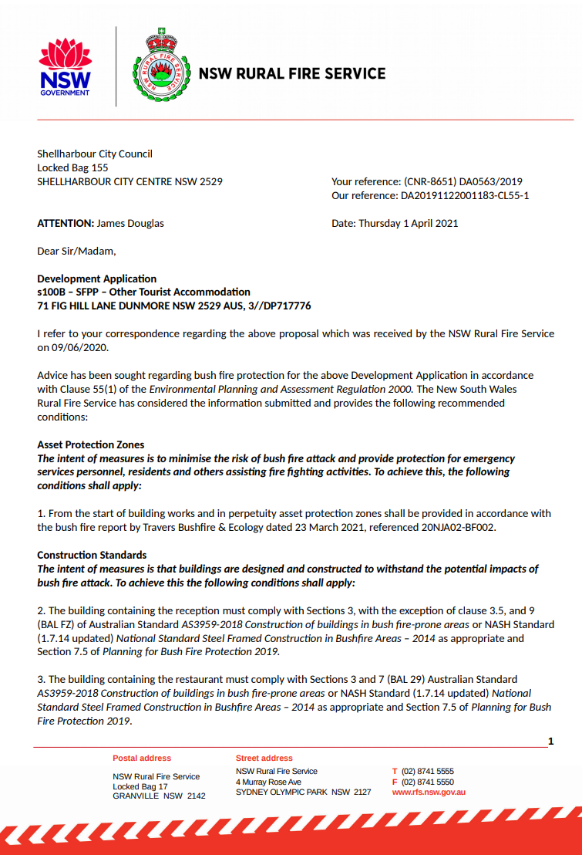

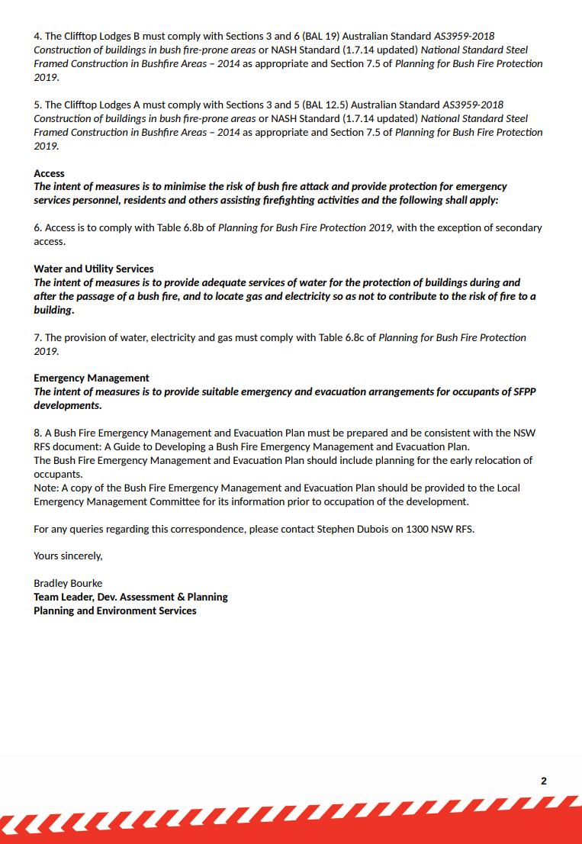

**76. Attachment 2 Endeavour Energy Response**

The General Manager

Shellharbour City Council

**ATTENTION: James Douglas, Senior Development Assessment Officer**

Dear Sir or Madam

I refer to Council’s letter of 14 November 2019 regarding Development Application No. 0563/2019 at 71 Fig Hill Lane, Dunmore (Lot 3 DP 717776) for ‘Redevelopment Of Site As An Eco-Tourist Facility Comprising Of A Part Two Storey, Part Three Storey Principal Building With 13 Guest Rooms, A Gym And Spa Area, Restaurant, Lounge Bar, Terrace And Pool Area, Rooftop Bar And Three Separated One Storey Pavilions Containing 20 Additional Guest Rooms (Eco Tourist Facility)’. Submissions need to be made to Council by 5 December 2019.

As shown in the below site plans from Endeavour Energy’s G/Net master facility model (and extracts from SIX Maps) there is:

* An easement over the site benefitting Endeavour Energy (indicated by red hatching) for low voltage overhead power lines.
* Low voltage overhead service conductor coming from a pole in the easement to the customer connection point for the existing dwelling / building on the site

Please note the location, extent and type of any electricity infrastructure, boundaries etc. shown on the plan is indicative only. Generally (depending on the scale and/or features selected), low voltage (normally not exceeding 1,000 volts) is indicated by blue lines and high voltage (normally exceeding 1,000 volts but for Endeavour Energy’s network not exceeding 132,000 volts / 132 kV) by red lines (these lines can appear as solid or dashed and where there are multiple lines / cables only the higher voltage may be shown). This plan only shows the Endeavour Energy network and does not show electricity infrastructure belonging to other authorities or customers owned electrical equipment beyond the customer connection point / point of supply to the property. This plan is not a ‘Dial Before You Dig’ plan under the provisions of Part 5E ‘Protection of underground electricity power lines’ of the *Electricity Supply Act 1995* (NSW).

Endeavour Energy is currently experiencing a problem in the Southern Region (particularly in non-urban areas) with its pole location data base interfacing with the Land Registry Services database. This results in the location of easements and electricity infrastructure not being shown in the correct location on Endeavour Energy’s G/Net master facility model. The below extract of RPM 10474 showing the correct location of the easements for overhead power lines.

Subject to the following recommendations and comments Endeavour Energy has no objection to the Development Application.

* Network Capacity / Connection

Endeavour Energy has noted that the Statement of Environmental Effects does not appear to address in detail if the electricity services are available and adequate for the proposed development.

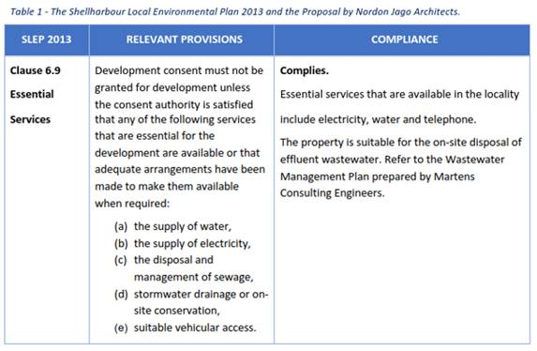

The availability of electricity supply to a site is based on a wide range of factors eg. the age and design of the network; other development in the locality utilising previously spare capacity within the local network; the progress of nearby / surrounding sites including electricity infrastructure works eg. a smaller and isolated development that may not of its own accord require a distribution substation may require a substation to facilitate the development and from which the spare capacity is made available to subsequent nearby development. Older / non-urban above ground areas of the network utilising pole mounted substations have comparatively limited capacity of 25 kilovolt amperes (kVA) up to a maximum of 400 kVA ie. there is a significant variation in the number and type of premises able to be connected to a substation.

Applicants should not automatically assume that the presence of existing electricity infrastructure or nearby similar development means that adequate supply is immediately available to facilitate their proposed development. The closest existing pole mounted substation no. 40895 (indicated by the symbol cid:image002.png@01D5A35B.DCF0AED0on the site plan from Endeavour Energy’s G/Net master facility model) located to the north within the easement on Lot 501 DP 1174897 currently has 4 customer connection points servicing 6 premises. Whilst there is likely to be some spare capacity, the pole mounted substation is not intended or capable of servicing a significant development. An extension and/or augmentation of the existing local network is likely to be required but this will not be determined until the final load assessment is completed. Endeavour Energy’s preference is to alert proponents / applicants (and Council) of the potential matters that may arise as further development of non-urban areas continues to occur.

In due course the applicant for the proposed development of the site will need to submit an application for connection of load via Endeavour Energy’s Network Connections Branch to carry out the final load assessment and the method of supply will be determined. Depending on the outcome of the assessment, any required padmount substation will need to be located within the property (in a suitable and accessible location) and be protected (including any associated cabling) by an easement and associated restrictions benefiting and gifted to Endeavour Energy. Please refer to Endeavour Energy’s Mains Design Instruction MDI 0044 ‘Easements and Property Tenure Rights’. Further details are available by contacting Endeavour Energy’s Network Connections Branch via Head Office enquiries on telephone: 133 718 or (02) 9853 6666 from 8am - 5:30pm or on Endeavour Energy’s website under ‘Home > Residential and business > Connecting to our network’ via the following link:

<http://www.endeavourenergy.com.au/> .

Advice on the electricity infrastructure required to facilitate the proposed development (including asset relocations) can be obtained by submitting a Technical Review Request to Endeavour Energy’s Network Connections Branch, the form for which FPJ6007 is attached and further details (including the applicable charges) are available from Endeavour Energy’s website under ‘Our connection services’. The response to these enquiries is based upon a desktop review of corporate information systems, and as such does not involve the engagement of various internal stakeholders in order to develop a ‘Connection Offer’. It does provide details of preliminary connection requirements which can be considered by the applicant prior to lodging a formal application for connection of load.

Alternatively the applicant should engage an Accredited Service Provider (ASP) of an appropriate level and class of accreditation. The ASP scheme is administered by Energy NSW and details are available on their website via the following link or telephone 13 77 88:

<https://energy.nsw.gov.au/government-and-regulation/legislative-and-regulatory-requirements/asp-scheme-and-contestable-works> .

* Bushfire

Endeavour Energy has noted that the Statement of Environmental Effects indicates that ‘Part of the land is mapped as being Bushfire Prone’. The accompanying Bushfire Protection Assessment which provides and assessment of the site having regards to NSW Rural Fire Service ‘Planning for Bush Fire Protection 2006’ does not appear to include any advice in regard to electricity infrastructure.

NSW Rural Fire Service ‘Planning for Bush Fire Protection 2006’ as a general bush fire protection measures requires that electricity should be located so as not to contribute to the risk of fire or impede the fire fighting effort and provides the following advice:

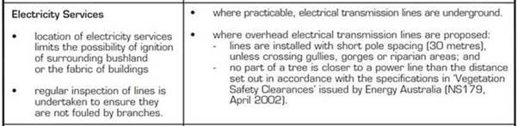

The following is an extract of Endeavour Energy’s Company Policy 9.1.1 Bushfire Risk Management:

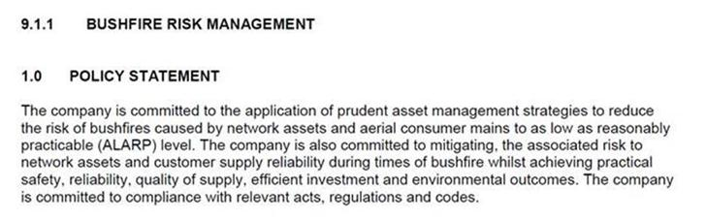

Accordingly the network required to service the proposed development must be fit for purpose and meet the technical specifications, design, construction and commissioning standards based on Endeavour Energy’s risk assessment associated with the implementation and use of the network connection / infrastructure for a bushfire prone site. In assessing bushfire risk, Endeavour Energy has traditionally focused on the likelihood of its network starting a bushfire, which is a function of the condition of the network. Risk control has focused on reducing the likelihood of fire ignition by implementing good design and maintenance practices. However safety risks associated with the loss of electricity supply are also considered.

* Flooding

Endeavour Energy has noted that the Statement of Environmental Effects indicates that ‘The subject site contains low lying level land along the Minamurra River which is considered to be flood liable.

Overhead power lines which can be damaged by flying or floating debris, falling trees and branches and inundation by floodwater. The main guide to the construction of overhead power lines is AS/NZS 7000:2016 Australian/New Zealand Standard ‘Overhead line design’ as updated from time to time which has specific as well as general guidance in regard to design of overhead power lines in flood prone land. Whenever possible any electricity infrastructure should be located outside of any flood affected areas.

Distribution substations should not be subject to flood inundation or stormwater runoff ie. the padmount substation cubicles are weather proof not flood proof and the cable pits whilst designed to be self draining should not be subject to excessive ingress of water. Section 7 ‘Substation and switching stations’ of Endeavour Energy’s Mains Construction Instruction MCI 0006 ‘Underground distribution construction standards manual’ provides the following details of the requirements for flooding and drainage in new padmount substation locations.

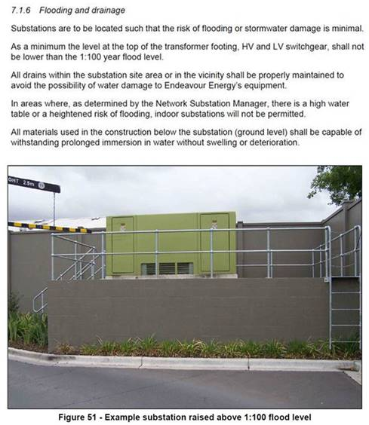

* Earthing

The construction of any building or structure (including fencing, signage, flag poles, hoardings etc.) whether temporary or permanent that is connected to or in close proximity to Endeavour Energy’s electrical network is required to comply with Australian/New Zealand Standard AS/NZS 3000:2018 ‘Electrical installations’ as updated from time to time. This Standard sets out requirements for the design, construction and verification of electrical installations, including ensuring there is adequate connection to the earth. Inadequate connection to the earth to allow a leaking/fault current to flow into the grounding system and be properly dissipated places persons, equipment connected to the network and the electricity network itself at risk from electric shock, fire and physical injury.

* Easement Management / Network Access

The following is a summary of the usual / main terms of Endeavour Energy’s electrical easements requiring that the landowner:

* Not install or permit to be installed any services or structures within the easement site.
* Not alter the surface level of the easement site.
* Not do or permit to be done anything that restricts access to the easement site without the prior written permission of Endeavour Energy and in accordance with such conditions as Endeavour Energy may reasonably impose.

Endeavour Energy’s preference is for no activities or encroachments to occur within its easements. However, if any proposed works (other than those approved / certified by Endeavour Energy’s Network Connections Branch as part of an enquiry / application for load or asset relocation project) will encroach/affect Endeavour Energy’s easements, contact must first be made with the Endeavour Energy’s Easements Officer, Jennie Saban, on mobile 0417484402 or alternately via email [Jennie.Saban@endeavourenergy.com.au](mailto:Jennie.Saban@endeavourenergy.com.au) or [Easements@endeavourenergy.com.au](mailto:Easements@endeavourenergy.com.au) .

Please find attached for the applicant’s reference copies of Endeavour Energy’s:

* General Restrictions for Overhead Power Lines.
* Mains Design Instruction MDI 0044 ‘Easements and Property Tenure Rights’ which deals with activities / encroachments within easements.
* Guide to Fencing, Retaining Walls and Maintenance Around Padmount Substations – which may be relevant should a padmount substation be required on the site.

It is imperative that the access to the existing electrical infrastructure on and in proximity of the site be maintained at all times. To ensure that supply electricity is available to the community, access to the electricity infrastructure may be required at any time. Restricted access to electricity infrastructure by maintenance workers causes delays in power restoration and may have severe consequences in the event of an emergency.

* Prudent Avoidance

The electricity network is operational 24/7/365 ie. all day, every day of the year. The electricity industry has adopted a policy of prudent avoidance by doing what can be done without undue inconvenience and at modest expense to avert the possible risk to health from exposure to emissions form electricity infrastructure such as electric and magnetic fields (EMF) and noise which generally increase the higher the voltage ie. Endeavour Energy’s network ranges from low voltage (normally not exceeding 1,000 volts) to high voltage (normally exceeding 1,000 volts but not exceeding 132,000 volts / 132 kV).

In practical terms this means that when designing new transmission and distribution facilities, consideration is given to reducing exposure and increasing separation distances to more sensitive uses such as residential or schools, pre-schools, day care centres or where potentially a greater number of people are regularly exposed for extended periods of time.

These emissions are usually not an issue but with Council’s permitting or encouraging development with higher density, reduced setbacks and increased building heights, but as the electricity network operates 24/7/365 (all day, every day of the year), the level of exposure can increase.

Endeavour Energy believes that irrespective of the zoning or land use, applicants (and Council) should also adopt a policy of prudent avoidance by the siting of more sensitive uses eg. the office component of an industrial building, away from and less susceptible uses such as garages, non-habitable or rooms not regularly occupied eg. storage areas in a commercial building, towards any electricity infrastructure – including any possible future electricity infrastructure required to facilitate the proposed development.

Where development is proposed in the vicinity of electricity infrastructure, Endeavour Energy is not responsible for any amelioration measures for such emissions that may impact on the nearby proposed development.

Please find attached a copy of Energy Networks Association’s ‘Electric & Magnetic Fields – What We Know’ which can also be accessed via their website at <https://www.energynetworks.com.au/electric-and-magnetic-fields> and provides the following advice:

*Electric fields are strongest closest to their source, and their strength diminishes rapidly as we move away from the source.*

*The level of a magnetic field depends on the amount of the current (measured in amps), and decreases rapidly once we move away from the source.*

Typical magnetic field measurements associated with Endeavour Energy’s activities and assets given the required easement widths, safety clearances etc. and having a maximum voltage of 132,000 volt / 132 kV, will with the observance of these separation distances not exceed the recommended magnetic field public exposure limits.

* Vegetation Management

The planting of large trees in the vicinity of electricity infrastructure is not supported by Endeavour Energy. Suitable planting needs to be undertaken in proximity of electricity infrastructure (including any new electricity infrastructure required to facilitate the proposed development). Only low growing shrubs not exceeding 3.0 metres in height, ground covers and smaller shrubs, with non-invasive root systems are the best plants to use. Larger trees should be planted well away from electricity infrastructure (at least the same distance from overhead power lines as their potential full grown height) and even with underground cables, be installed with a root barrier around the root ball of the plant.

Landscaping that interferes with electricity infrastructure may become a potential safety risk, cause of bush fire, restrict access, reduce light levels from streetlights or result in the interruption of supply. Such landscaping may be subject to Endeavour Energy’s Vegetation Management program and/or the provisions of the *Electricity Supply Act 1995* (NSW) Section 48 ‘Interference with electricity works by trees’ by which under certain circumstances the cost of carrying out such work may be recovered.

* Dial Before You Dig

Before commencing any underground activity the applicant is required to obtain advice from the ***Dial Before You Dig* 1100** service in accordance with the requirements of the *Electricity Supply Act 1995* (NSW) and associated Regulations. This should be obtained by the applicant not only to identify the location of any underground electrical and other utility infrastructure across the site, but also to identify them as a hazard and to properly assess the risk.

* Public Safety

Workers involved in work near electricity infrastructure run the risk of receiving an electric shock and causing substantial damage to plant and equipment. I have attached Endeavour Energy’s public safety training resources, which were developed to help general public / workers to understand why you may be at risk and what you can do to work safely. The public safety training resources are also available via Endeavour Energy’s website via the following link:

<http://www.endeavourenergy.com.au/wps/wcm/connect/ee/nsw/nsw+homepage/communitynav/safety/safety+brochures> .

If the applicant has any concerns over the proposed works in proximity of the Endeavour Energy’s electricity infrastructure to the road verge / roadway, as part of a public safety initiative Endeavour Energy has set up an email account that is accessible by a range of multiple stakeholders across the company in order to provide more effective lines of communication with the general public who may be undertaking construction activities in proximity of electricity infrastructure such as builders, construction industry workers etc. The email address is [Construction.Works@endeavourenergy.com.au](mailto:Construction.Works@endeavourenergy.com.au) .

* Emergency Contact

In case of an emergency relating to Endeavour Energy’s electrical network, the applicant should note the Emergencies Telephone is 131 003 which can be contacted 24 hours/7 days. Endeavour Energy’s contact details should be included in any relevant risk and safety management plan.

I appreciate that not all the foregoing issues may be directly or immediately relevant or significant to the Development Application eg. if a padmount substation is not required on the site. However, Endeavour Energy’s preference is to alert proponents / applicants of the potential matters that may arise should development within closer proximity of the existing and/or required electricity infrastructure needed to facilitate the proposed development on or in the vicinity of the site occur.

Could you please pass on a copy of this submission and the attached resources to the applicant? Should you wish to discuss this matter, or have any questions, please do not hesitate to contact me or the contacts identified above in relation to the various matters. Due to the high number of development application / planning proposal notifications submitted to Endeavour Energy, to ensure a response contact by email to [property.development@endeavourenergy.com.au](mailto:property.development@endeavourenergy.com.au) is preferred.

Yours faithfully

Cornelis Duba

Development Application Specialist

Network Environment & Assessment

T: 9853 7896

E: [cornelis.duba@endeavourenergy.com.au](mailto:cornelis.duba@endeavourenergy.com.au)

51 Huntingwood Drive, Huntingwood NSW 2148

[**www.endeavourenergy.com.au**](http://www.endeavourenergy.com.au)

cid:image006.png@01D5A35B.DCF0AED0

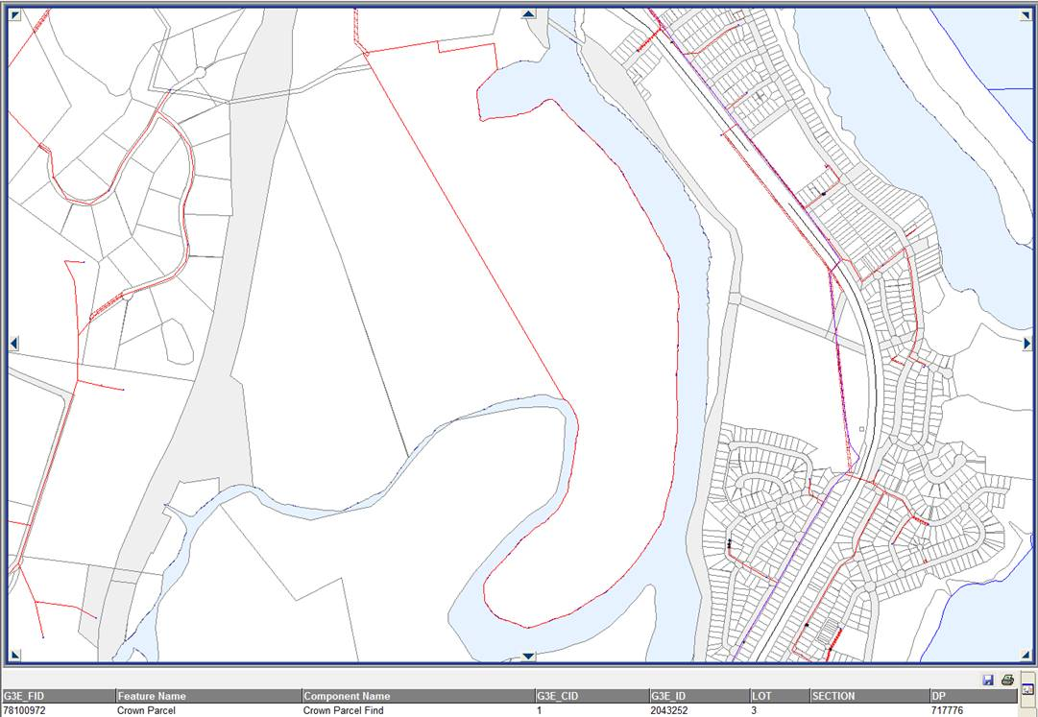

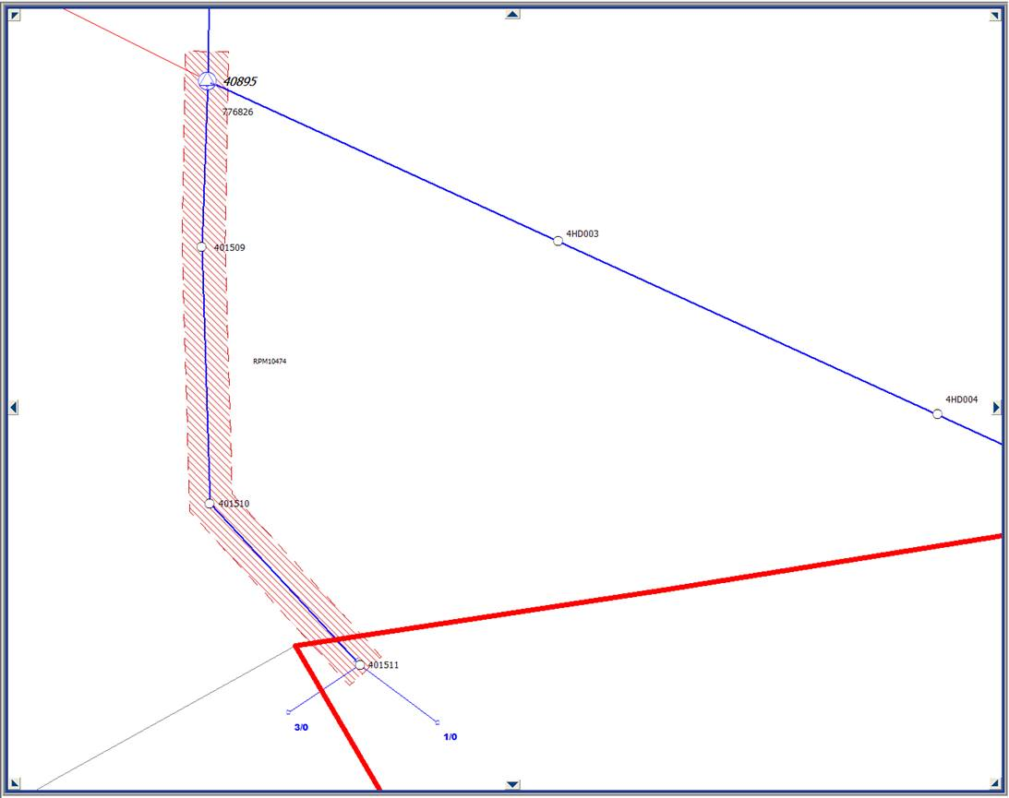

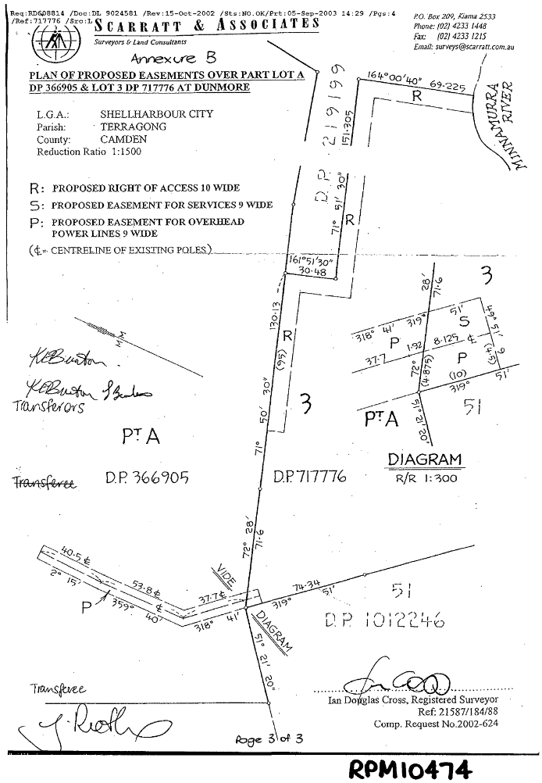

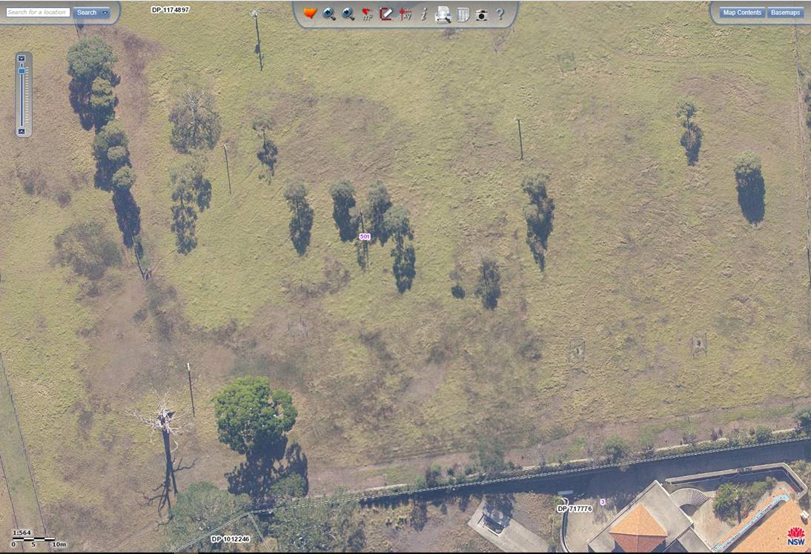

**Advisory Notes – General**

**Compliance with *Building Code of Australia***

The development must comply with the *Building Code of Australia* and all related standards and legislation.

**Critical Stage Mandatory Inspections**

Mandatory inspections of the building work must be carried out by the Principal Certifying Authority at various stages of construction in accordance with clause 162A of the *Environmental Planning & Assessment Regulation 2000.*

It is recommended that you discuss with your Principal Certifier the occasions when the building work is to be inspected prior to work commencing.

**Erection of Signs**

The principal contractor and the Principal Certifying Authority will need to have a sign (or signs) erected and maintained on the development site that provides their name and contact telephone number (during and outside work hours for the principal contractor), and stating that unauthorised entry to the site is prohibited. The principal contractor and Principal Certifying Authority can have separate signs or they can both use one sign if they choose.

A maximum penalty of 10 penalty units applies for failure to erect and maintain sign(s) detailing principal contractor and Principal Certifying Authority identification.

**WorkCover Authority**

The requirements of NSW Safework must be satisfied at all times.

**Failure to Comply with Consent**

Failure to comply with any of the conditions of consent may result in a Penalty Infringement Notice being issued against the owner/applicant/builder. Substantially greater penalties may be imposed by the Court for non-compliance.

**Lapsing of Development Consent**

In accordance with section 95 of the *Environmental Planning & Assessment Act 1979*, the development approval lapses five years after the approval date unless building, engineering or construction work relating to the building has physically commenced.

**Right to Appeal**

If you are dissatisfied with this decision, Part 8, Division 8.3, section 8.7 of the *Environmental Planning & Assessment Act 1979* gives you the right to appeal to the Land & Environment Court within twelve months after the date on which you receive this notice.

**Review of Determination**

If you are dissatisfied with this decision, Part 8, Division 8.2 of the *Environmental Planning & Assessment Act 1979* provides that you may request Council to review its determination. The request cannot be made after the time limit for making of an appeal under section 97 expires.

Division 8.2 of the *Environmental Planning & Assessment Act 1979* does not apply to:

a. a determination to issue or refuse to issue a complying development certificate

b. a determination in respect of designated development

c. a determination in respect of integrated development

d. a determination made by the Council under Division 4 in respect of an application made by the Crown.

**To Vary Development Consent**

The plans and/or conditions of this consent are binding and may only be varied upon application to Council under section 96 of the *Environmental Planning & Assessment Act 1979*. The appropriate fee shall accompany the application and no action shall be taken on the requested variation unless and until the written authorisation of Council is received by way of an amended consent.

**Development within Vicinity of a High Pressure Gas Main**

Contact Dial Before You Dig on 1100 or www.dialbeforeyoudig.com.au <http://www.dialbeforeyoudig.com.au/> Proposed works in the vicinity of any high pressure gas main must be directed to:

Jemena Asset Management Pty Ltd

PO Box 6507

SILVERWATER NSW 2128

Attention: Land Services Department

**Dial Before You Dig**

Before commencing any underground activity the applicant is required to obtain advice from the *Dial Before You Dig* 1100 service in accordance with the requirements of the *Electricity Supply Act 1995* (NSW) and associated Regulations. This should be obtained by the applicant not only to identify the location of any underground electrical and other utility infrastructure across the site, but also to identify them as a hazard and to properly assess the risk.

**Liquor Licencing**

Prior to the serving of any alcohol within the restaurant/bar area, the development will also require consent from the Independent Liquor and Gaming Authority (ILGA) as required by the Liquor Act 2007.